Generation of Synthetic datasets for educational or training use

Peter Henry

Submitted in partial fulfilment of
the requirements of Edinburgh Napier University
for the Degree of
BSc (Hons) Computing Science

School of Computing
July 2020
Authorship Declaration
I, Peter Henry, confirm that this dissertation and the work presented in it are my own achievement.
Where I have consulted the published work of others this is always clearly attributed;
Where I have quoted from the work of others the source is always given. With the exception of such quotations this dissertation is entirely my own work;
I have acknowledged all main sources of help;
If my research follows on from previous work or is part of a larger collaborative research project I have made clear exactly what was done by others and what I have contributed myself;
I have read and understand the penalties associated with Academic Misconduct.
I also confirm that I have obtained informed consent from all people I have involved in the work in this dissertation following the School's ethical guidelines

Signed:

Date: August 2020

Matriculation no: 40276792

General Data Protection Regulation Declaration
Under the General Data Protection Regulation (GDPR) (EU) 2016/679, the University cannot disclose your grade to an unauthorised person. However, other students benefit from studying dissertations that have their grades attached.

Please sign your name below one of the options below to state your preference.

The University may make this dissertation, with indicative grade, available to others.

The University may make this dissertation available to others, but the grade may not be disclosed.

The University may not make this dissertation available to others.

Abstract
Genuine, real world datasets come with a number of caveats – they are often messy, including incomplete entries, erroneous values or corrupted data. These issues all require significant effort to sort, and thus where it is possible to use fake, generated data it is generally a good idea to do so. This project aims to create a method of randomly generating datasets for educational and training purposes. This not only allows faster access to new data, but also gives greater control over how simple the data is to analyse, allowing the user to scale difficulty depending on the level of the course being undertaken by reducing the severity of the noise in the data. This project investigates some previous work in the field, as well as detailing and justifying the tools and methods that were used for the project. It will then describe the dataset generation tool that was created to address the aforementioned issues, and finally evaluate it to determine the project’s success in terms of balancing realism and simplicity for use in an undergraduate level computing module.
Contents
1 Introduction 9
1.1 Background 9
1.2 Aims and objectives 10
1.3 Scope and limitations 11
1.4 Structure of the dissertation 12
2 Literature review 13
2.1 The issues with randomness 13
2.2 Tools 14
2.3 Problems with data 16
2.4 Data analysis 17
3 Design 19
4 Implementation, Results and Visual Analysis 21
4.1 The original dataset creator 21
4.2 The distributable version of the tool 22
4.3 The Parameter file 36
4.4 The testing version of the tool 38
4.5 Issues encountered 39
4.6 Project management 40
5 Evaluation 42
5.1 Visual and objective analysis 42
5.2 Weka Explorer Analysis 45
6 Conclusions and future work 55
6.1 Objective summary of the project 55
6.2 Potential future extensions 55
6.3 Lessons learned 56

List of Tables
Table 1 Error: Reference source not found5

List of Figures
Figure 1. 2Error: Reference source not found
Figure 2. 2Error: Reference source not found
Figure 3. 2Error: Reference source not found
Figure 4. 28
Figure 5. 29
Figure 6. 29
Figure 7. 31
Figure 8. 32
Figure 9. 33
Figure 10. 34
Figure 11. 35
Figure 12. 36

Acknowledgements
Thanks go to my new wife, Silvia, for her support and assistance with formatting the report.
Thanks also go to my supervisor for this project, Peter Chapman, for providing his knowledge for the ideas that formed this project, as well as for giving the dataset creation script from the Data Analytics module to be used as a base for the development.
Finally thanks to my brother, Christopher, for the fantastic idea of using a .csv for parameters rather than just having them at the beginning of the R script.

Introduction

Background
This project started out with a problem. This was that there was a lack of simple and fast to use data generators for educational purposes which provided realistic material for students to work with. This is highlighted by the first coursework for the Data Analytics module at Edinburgh Napier University, which used an entirely hard-coded method of creating the data. This meant that to alter the coursework for students sitting the module in following years or as part of a resit, a significant amount of time and effort would need to be put into changing the code to create different data. In addition to this, the data created was somewhat unnatural in appearance, with correlations between variables often being completely linear. This means that the coursework is not able to educate the students as well as real data would be able to, specifically in that it does not require such deep investigation to discover the relationships and may cause confusion among students when faced with real data where they are less pronounced. However, using real data as part of a coursework is also problematic, as a large amount of data available is subject to data protection laws. In addition to this, much of the publicly available data will already have been analysed, allowing students to easily search for information online to “cheat” in the coursework, giving them an unfair advantage. What’s more, real data may not have meaningful relationships in it at all, or they might be either too difficult or too simple for the level of the course being undertaken. Having to search through many datasets to find a suitable one which fits all these requirements is highly time consuming, and thus using generated data is more suitable.
This project was chosen as data in general is an interesting and deep subject in which there is a significant amount of new work that can be done. A significant inspiration was the first coursework for Data analytics – a third year module at Edinburgh Napier University. This also served as a baseline for the project with Peter Chapman, the module leader, generously providing the R files used to create the dataset for that coursework.
There has been surprisingly little work done in the synthetic data generation for education field, but projects such as synthpop (Nowok, Raab, & Dibben, 2016) and Simple Integrated Land Use Orchestrator (Moeckel, 2018) have allowed for creation of data using samples of real personal data so that it avoids conflicting data protection laws. Beyond this, (Smith, Clarke, & Harland, 2009) have investigated using simulated populations to predict how alterations in council or governmental regulations and laws would impact society.

Aims and objectives
The main aim of this project is to gain an understanding of data and randomness, then putting these together to create a tool which produces synthetic data that is close in appearance to real data.
More specifically the project will focus on:
- Making a synthetic dataset generator tool that gives sufficient control to the creator of the dataset
- Minimising the amount of time required to create the data
- Providing options for specifying relationships within the data, naming categories, and the amount that the data is fuzzified – i.e. how much random jitter is applied to the values to imitate real data.
This will solve the issues highlighted in section 1.1 by allowing professors creating courseworks in the data analytics field to have easy access to unique data which is suitable for usage in educational scenarios. It could also be used in the commercial sector as training data for new or potential employees.

The secondary objectives for the project are as follows:
- The tool must expand on previous work in the data generation field and offer functionality that differs from other tools and programs that are currently available
- The tool should be easy to understand and work with, allowing rapid creation of a dataset with given parameters without any need to alter parameters
- The parameters should offer a great depth of customisation so that the user can specify how they want the data to be in terms of relationships and of how clean and ready the dataset is for analysis.

Overall, this project aims to deliver a working method of generating datasets which have pre-specified parameters and relationships. The datasets should be believably random in nature and appearance. There will be a reasonable degree of customisation allowed, with the strength of relationships, category names and values, and ranges for numerical values.

Scope and limitations
This project focuses on understanding data and using computers to generate it. It investigates previous work in the field and also shows the implementation of a new tool created as part of the project. The project does not focus on the refinement of the product into something that is commercially viable, though this may be a viable direction in future work, depending on the success of the programming aspect of the project. It will also not be made completely unbreakable, with no limit on the values that can be used as parameters. This could also be done in the future to prevent errors, but as this is not a software engineering project, and the people who would be using this tool will have a good level of knowledge and understanding of data creation, it was not considered necessary to make this a focus of the project.
This project is time limited, as there is no clear end to the research that could be done, or the possibilities that could be explored to improve the tool. As a result, the research will have to be mostly finished within the first few months of the project, so that time is left for the programming, evaluation, and compilation of the dissertation. The programming aspect will focus on improving every aspect of the program as much as possible within the timescale assigned to that part of the project.
The research for the project was carried out mostly using the Edinburgh Napier Library’s Library Search, though Google Scholar was also used where more articles were desired. In addition to these, some referenced material is from documentation for the tools used, whereas others are just to websites. For the literature review in particular, peer-reviewed journals were used where possible, which was limiting to a degree, but ensured that the material certified to be of a high quality.

Structure of the dissertation
- Introduction – giving a general overview of what the dissertation is about by highlighting the background, aims and objectives, and scope and limitations of the project.
- Literature review – this will synthesise the various publications, journals and products that were used in the research for the project. Also shows how they justify the way the programming part of the project was carried out.
- Design – short specification of what needs to be undertaken in the implementation section.
- Implementation – description of tool made to create datasets for educational use.
- Evaluation – determine the success of the tool shown in the implementation section.
- Conclusion – analysis of the project as a whole to show areas where it was successful, as well as points where it failed, or could be improved upon.

Literature review
This literature review aims to demonstrate how the chosen methodology for the project can be justified by showing alternative methods or tools for each section of the project and comparing them to those that were selected. It will also attempt to guide the project in terms of the methods used for generating values to use in the dataset. It shall do this by investigating various ways of producing values that are close to the specified numbers but are also varied enough to be realistic and believable, while maintaining the ability to create significantly different data each time the program is run.
It will look at different methods for both sampling from a distribution and pseudorandom number generators. After this it will look at the strengths and weaknesses of the different methods and aim to come to a conclusion as to which is more suitable for this particular project.

The issues with randomness
This part of the paper will look into randomness; first attempting to define randomness, then investigating perceptions of randomness and pseudorandom number generators.

Randomness and Pseudorandomness
Randomness is defined in the Mirriam-Webster dictionary as “without definite aim, direction, rule, or method” (Mirriam-Webster, 2019). It has also been described as “the flip side of statistical structure” (Warren et al., 2018). In other words, randomness is used to describe something that is not predictable.
The term Pseudorandom is defined by the Mirriam-Webster dictionary as: “being or involving entities (such as numbers) that are selected by a definite computational process but that satisfy one or more standard tests for statistical randomness” (Mirriam-Webster, 2019). In other words, pseudorandomness describes things (typically numbers) that are not truly random but are in fact artificially produced values which are generated by computers. It has also been described as “the theory of efficiently generating objects that "look random" despite being constructed using little or no randomness.” (Vadhan, 2011). These two definitions agree that pseudorandom means not truly random but clash as to whether or not computers have to be involved in their creation.

Humans and randomness
The way that people perceive randomness is often said to be influenced by external factors, thus making them more likely to prefer or choose certain numbers when asked to provide a “random” one (Warren et al., 2018). It has been said that humans are not particularly adept at distinguishing what is random (Reimers, Donkin, & Le Pelley, 2017). This would suggest that it would be easy to “trick” people into believing that values which are produced by a pseudorandom number generator are indeed random. The experiments of Reimers Et al. find that there are tendencies for people to assume that something is not random if it produces consistent results. It shows how people typically expect a balance when a selection of randomly generated values is produced and are likely to doubt the legitimacy of a system if they see it producing results which appear to be skewed. This belief can be clearly demonstrated by looking at people’s attitudes towards gambling, where it can be seen that people have an urge to continue whilst they are “losing” due to them being under the misconception that their results are likely to level out (Ladouceur, Ferland, & Maude Fournier, 2013).

Tools
This project will consist of two main parts. Firstly, R will be used for creating the datasets as it is straightforward and is widely used by data analysts both within and outside the educational setting, ranking as the 8th most used programming language worldwide as of July 2020 (Tiobe, 2020). It also provides a wide variety of packages and tools to allow data to be created, manipulated, and explored. This includes multiple functions to generate pseudorandom numbers. In addition to these factors, the coursework that served as inspiration for the project used R to generate the dataset, so with the absence of any significant shortcomings, it makes sense to stick with R.
Python was also considered, as it also offers a large amount of tools designed for data creation and analysis workloads is even more popular than R - though it is also suitable for other programming applications than and is not designed exclusively for working with data (Banerjee, 2015). It offers various tools which mean that it would be suitable as an alternative for this project. R was chosen due to prior experience and knowledge, alongside the existing projects written in it for coursework data creation. Its more focused nature also makes it easier to find desired extensions or packages.
C# may also be used for designing and creating an application with a simple user interface which allows the end user to configure the data the way they want it. It is suitable because it is a language which is easy to use and the visual studio IDE offers an in-built GUI creator that enables fast creation of a usable interface design. This is more of a secondary objective and is not a vital part of the project.

R
R is a programming language that is designed to cater to statistical programming needs (“R: The R Project for Statistical Computing,” 2018). It is described in the official documentation as “an integrated suite of software facilities for data manipulation, calculation and graphical display”. This means that it provides a one-stop shop for Data scientists through the “Comprehensive R Archive Network (CRAN)” (Renard, 2011). R is fully Open Source. This allows for “packages” to be developed and seamlessly integrated into R. These packages extend the language by adding new methods and functions. R itself, along with a vast library of packages, is entirely free to download, with only commercial organisations having to pay for a license.

C#
C# may also be used in the project, utilising Visual Studio 2017 as the Development environment. It would be used purely to assign values to guide the data, then to generate R code to create the dataset. This code would be largely pre-written, with the program simply choosing which parts of the code to implement and what values to set in the parameters. This would be done in a custom-built UI, detailing the various parameters that the end user (in this case, module leaders at universities) can modify to customise the dataset that is generated. C# is suitable for this as it is simple to develop in, provides a variety of advanced debugging tools and allows easy creation of a user interface (Microsoft, 2017). The User interface creator is very powerful while maintaining the ability to easily align items, with options to either use the automatic snapping feature or manually edit the XML. Visual Studio also offers a UI testing feature (Manoj et al., 2018) which allows programmers to ensure that their UI is working properly with few lines of code. Usefully, this also allows the UI to be edited, without needing to rewrite the test code.

Problems with data

Data privacy and availability
Obtaining real data can be a highly significant challenge to overcome. There have been many attempts to increase the amount of available data. One particular attempt is Synthpop, a package for R (Nowok, Raab, & Dibben, 2016). This package aims to create synthetic populations from real samples for the purpose of providing data which mimics real data closely enough to be useful for statistical analysis, but that does not disclose any personal information. The journal which accompanies the Synthpop, written by the creators of the package, explains that it is difficult and potentially quite costly to get hold of data which contains personal information about individuals. As a result of the recent GDPR data protection act, it is increasingly difficult to legally obtain data due to the act ensuring that all people should have the “right to be forgotten” (Meinert, 2018). In addition to this, whether people wish to have their records deleted or not, it is also necessary for companies to erase personal data when it is no longer justifiably needed.
The availability of data in general can be described as “the degree of convenience for users to obtain data and related information” (Costa et al., 2019) as it refers to the effort and cost required to access the data (assuming it is legally possible to get this), how relevant the data is, and how well regarded and trustworthy the sources of the data are i.e. how likely it is to provide an accurate representation of the specific area it is alleged to represent.

Data preparation
Next, if data that is relevant has been obtained, it is necessary to look into the quality of the data and deal with it appropriately. So, what is data quality? It can be described as the “agreement between the data views presented by an information system and that same data in the real world” (Heinrich et al., 2018). As data invariably contains many errors, it is necessary to attempt to iron these out as effectively as possible. However, as is pointed out by Heinrich, there is often a conflict when attempting to make alterations to the data. Decisions often have to be made to either scrap a record from the data or make changes to certain values to allow it to comply with the ranges set for said values. This preparation stage can be extremely time and resource consuming, with it being reckoned to drain $3.1 trillion per year from US companies (Chiang & Gairola, 2018). This paper also highlights the issues that are raised when personal data has to be cleaned. As data cleaning often requires specific values to be picked out and altered, it tends to require a human to look at the data. This has the potential to unnecessarily reveal personal information to an individual and has required those with access to the data to be trusted to maintain confidentiality. Pérez say that data preparation takes up somewhere between 50 and 70% of the total time of a data mining project (Pérez et al.). This is backed up by Rapidminer platform which claims that these processes take around 80% of the time from a typical professional machine learning expert or data scientist’s job (Rapidminer, 2018). While this is unavoidable in many circumstances, for the purpose of this project, using an automatically generated dataset will cut out a vast amount of time compared to using a “real” dataset which has been sourced, pre-processed, cleaned and prepared. This is because the generator cuts out the majority of the time-consuming preparation as the user simply inputs parameters then presses a button to create a useable and unique dataset.

Data analysis
In this section, the concept of data analysis will be explored. This will be used as a method of evaluating the project, by taking generated datasets and running them through software to find what kinds of relationships they find.

Data analysis tools
R (“R: The R Project for Statistical Computing,” 2018) is a powerful tool for analysing data. It provides a vast range of functions within its many packages which allow creation of easily readable graphs and charts that display information from data.

Data mining tools
For this project, WEKA will be used for evaluation purposes (University of Waikato, 2016). This is a data mining program which enables multiple datasets to be automatically explored and exported to a file through the Weka Experimenter tool. This means that comparison of datasets is less time consuming, which allows for more to be done within the timescale set. This includes comparing multiple datasets which have been run with the same parameters to check for consistency and uniqueness, as well as comparing these to the results found from the original dataset that was used for the data analytics coursework 1. Weka also has a more detailed tool called Explorer, which only allows analysis of a single dataset at a time but gives more information about them. As highlighted in “Data mining in bioinformatics using Weka” (Frank et al., 2004), Weka provides tools to deal with classification, regression, and clustering problems, with multiple algorithms being available for each. This provides a vast amount of options for examining the datasets, which is ideal, but it is also time consuming to determine which are best suited to this specific problem.

Design
For the design of the data creation aspect of the project, an R script was decided on. This will be based on the original dataset creator authored by Peter Chapman. This will then be altered and improved to better suit the project and achieve the aims and objectives set out in section 1.2.
For the improvements, the file will be expanded upon to increase the functionality, as well as sections being replaced where it is necessary. The focus for this will be on two things: improving the apparent randomness of the data and improving the reusability and versatility of the code.
The tool uses the base rather than starting from scratch as there is no clear advantage to the latter – the existing code already carries a reasonable amount of the functionality desired from the end product of this project. This gives the project a head start and allows for more time to work on new developments, as well as experimenting with parameters and alternative methods of creating the data.
The design of the tool is fairly simple: create fields, then populate them with random (evenly distributed) data then add relationships by a mixture of modifying or overwriting existing values.
There will be a file from which the parameters will be set to then be read by the R program when it is run. This file will allow the user to adjust various aspects of the dataset so that they can specify it to their particular needs. It will encompass variables which control the strength of relationships, category names and values, plus the amount of randomised fuzziness to be added.
There may also be a program to help them edit this file, with a GUI that aids usage of the tool. This will only be implemented if there is time; most likely using C# and the Visual Studio Windows Platform App (WPF) tool. The user would input values into a form style window, which would then automatically create a parameters file. The program would also have features to save configurations so that they could easily be loaded and edited.
Another possible addition, provided there is time, would be an outlier creation function. This would populate the dataset with some randomised values at random points, to add some clutter for a more challenging experience when analysing and interpreting the data. This would allow the user to change the amount these values stuck out, as well as their frequency.

Implementation, Results and Visual Analysis
This section of the dissertation shall detail the implementation of the data creation tool in ‘R’. It shall explain the base for the project, what problems were encountered along the way, and how the original program was adapted to become the final version. It will also include some evaluation regarding the extent of the success of individual parts. This was included in this section because it aided the ease of reading due to the plots included for demonstrating the results also being relevant to the evaluation. In short, having visual evaluation here prevents the reader from having to flit back and forth to see the figures relevant to the text.
The implementation takes significant inspiration from the work of Peter Chapman and is used with his consent.

The original dataset creator
The original dataset creator was produced and provided by Peter Chapman, who previously taught SET09120 - the Data Analytics module which was a large part of the inspiration for this project. This program was written to create a synthetic dataset for analysis by students as part of their first coursework for the module. The dataset had specified relationships which the students were required to discover through using the various tools provided by R and RStudio. The column names are used throughout to alter the values that come under them. The column names are: "Gender","Location","Age","ss","sj","st","sd" and "so", with the latter five standing for sprint score, jump score, throwing score, distance score and overall score, respectively. As this was the first coursework for the module, and was worth fewer marks than the second one, it was designed to be easier to get started with and pass. Therefore, the relationships were made to be very clear and distinct, so that students were not confused. However, this had the side effect of the dataset not appearing to be realistic, thus not providing as much educational value as it potentially could. What’s more, the R program is coded in a way that was fit for the original purpose, but that makes it difficult and time consuming to alter for producing a significantly different dataset, with variables being hard coded and a lot of code repetition which would all have to be changed. Relationships are too smooth and linear.
Firstly, the dataset is initialised by creating forty separate vectors including any combination of three nominal variables, along with the five numeric variables set to 0. 250 of each of these are then created and added to a database, which gives us the 10000 records needed. This method does the job that it was intended to do but is rather hacky and difficult to expand upon. Next, the column names are added to this and it is all put together in a data frame and the numeric columns are set to numeric.
After this initialisation, the program starts to populate the values with the relationships that are desired. This is done using uniform distributions, which set strict limits on the upper and lower allowed values, and average around the centre point between these two. This means that values are very ‘uniform’ in their appearance and are evenly distributed across the range of possible values. The problem with this is when there is a specified relationship, values stick exactly to the range set and therefore end up appearing unnatural when viewed in isolation. Another issue with the way this is done is that every value is set manually, which means that every group of values is set individually, even if there is not to be a relationship in that part of the data.
Finally, the program calculates the overall scores as averages, with one score being skewed to not include a specified variable i.e. in this case, throw score for females is not taken into account, so the overall is calculated using the other three.
While overall this program does what it was intended to do, it is clear to see that there are areas which can be improved upon.

The distributable version of the tool
This version of the tool is what would be used for the basic creation of datasets with the parameters. It includes all the changes made to the way datasets are generated.
The program begins by loading the necessary packages using pacman (Package Management Tool [R package pacman version 0.5.1], n.d.), namely ggplot2, rio, and plyr. It then imports the Params.csv file from the user’s documents folder. This will be used throughout the program to specify values used within the creation of the data.
It then assigns all the desired possible values to their respective categorical column. At this point, the column names are stored, but they are not added to the dataset until later on. At this point, the dataset only allows for a fixed number of possible values for each categorical variable – specifically two for the first one, five for the second one, and four for the third one. This is obviously not ideal, as it cuts down on the amount of variance that is possible with the tool, but it was considered unnecessary to put time into that as it wouldn’t significantly improve the scope of the project from a computing science standpoint. This would be a worthwhile advancement for future work on the tool.
After the column names, it creates a random distribution of values within a specified range. These are used throughout to apply some ‘jitter’ to values and make them appear slightly rougher while not upsetting the relationships beyond recognition. This is done by running some code each time the variable J is called which sets it to one value further on in the jitter distribution. The categorical columns are combined using the merge function, then the numerical columns are added. This takes far less space than the previous solution of writing out each individual permutation of the categorical variables. The data is then added to a data frame, numeric columns declared as numeric (despite being initialised as 0, they default to characters), and the numerical columns populated with uniform distributions between zero and one hundred.
Now that the dataset is initialised, the relationships can be added. These are added in sequence, dealing with each relationship as a separate entity. For demonstration purposes, the relationships will be using the same category names and values as the original dataset creator. This was because there is no need to change them and it makes comparison with the original, and overall comprehension, easier – Gender = female is easier to visualise than CAT1 = [2].

First relationship
The first relationship involves scores for one categorical variable – in this case, distance scores – being boosted for people in a particular age group. This was one of the slightly less jarring relationships in the original, but it has been worked upon regardless. The user can input their desired values for the upper and lower bounds of each age group, allowing them to choose which are boosted, and by how much. This relationship also makes use of the universal user defined “jitter” value which is used to offset the values a bit to add some variation. This could also be done by the user by manually setting the values to be slightly different to each other, but the jitter method takes less time, especially if the user wants to use the default relationship values. The end result of this is a relationship that looks more natural than the original, with a less uniform look to the boxplot visualisation run with equivalent settings.

Second relationship
The second relationship involves boosting all overall score values in a specified location by a certain amount. Similar to the first relationship, the original wasn’t particularly out of place, so the most significant addition is the ability to change the values used in the relationships to create different datasets. The jitter is also being applied to these. For both this and the first relationship only small differences are made to the method of creating the data, but they can be configured to look more authentic, or more obvious, with different parameter values. Figure 1. And Figure 2. show how minimal the difference is when run with the same values as the original. Figure 3. shows how tuning of the parameters can make this appear far more believable. Of course, this is just an example and can be tuned to be either clearer or fainter, but it demonstrates the power that being able to specify the values, which takes a matter of seconds, gives to the user.
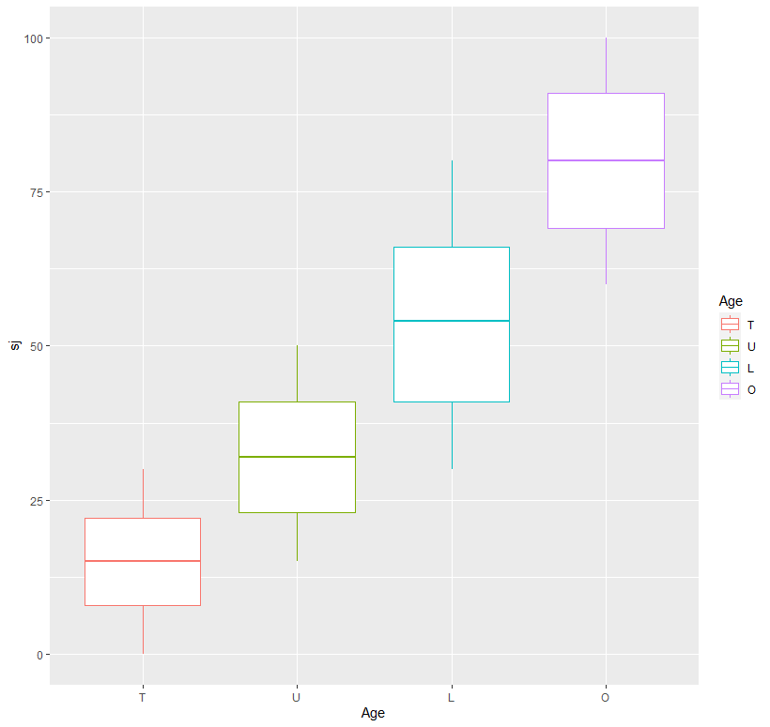
Figure 1. Original visualisation

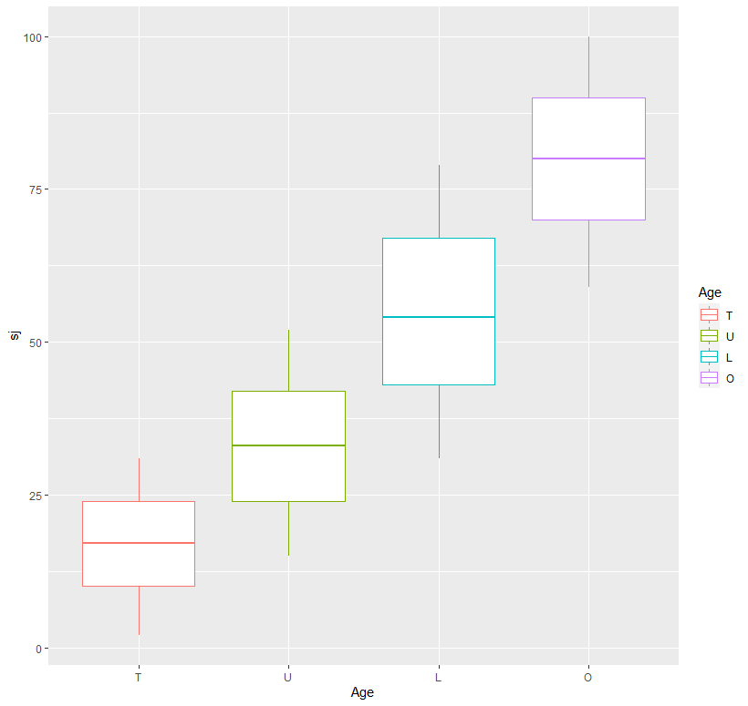
Figure 2. New visualisation
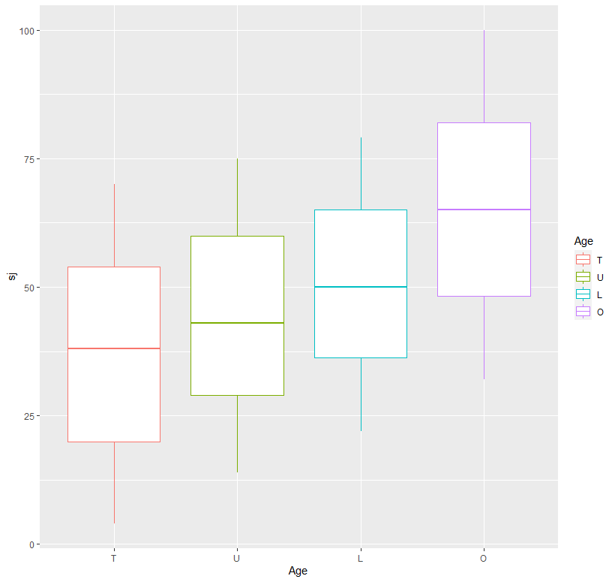
Figure 3. New visualisation with optimised values

Third relationship
The third relationship involves a relationship between two numerical variables, in this case demonstrated as Jumping score (sj) and Distance score (sd). This one is a bit more complicated, and problems were encountered which prevented it from behaving as desired. The original script produced a perfect parabolic relationship, shown below in Figure 4., which is very unlikely to be encountered in real data and therefore is not ideal for training purposes. The problem with this was that in the transition to from entirely hard-coded column names to the parameter-controlled ones, the function started to only produce higher values than desired, and only provides the second half of a parabolic curve. This issue was unfortunately not overcome before the conclusion of this project. Figure 4., Figure 5., and Figure 6. show the relationship created by the original, the new version without custom jitter, and the new version with custom jitter respectively. The custom jitter in this instance was more of a success, spreading results out significantly while maintaining a distinct curve. The strength of this jitter can be changed within the code, but a parameter was not added as it is easy to go too far in one direction with the values. The jitter here was implemented by multiplying the relevant values by a normal distribution with an average of one and a standard deviation of 0.05. This gives the data more volume when observed in a scatter plot. Overall, this relationship’s optimisations and improvements were not ideal but the jitter does show that there is promise for this type of relationship, should the range bug be fixed in the future.
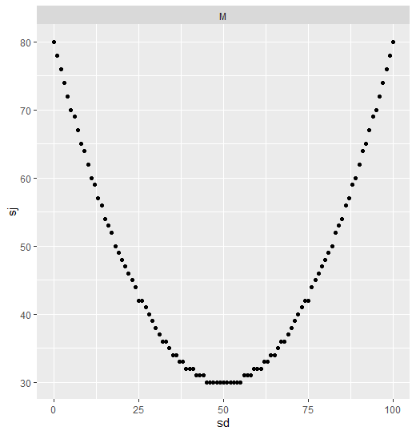
Figure 4. Original plot

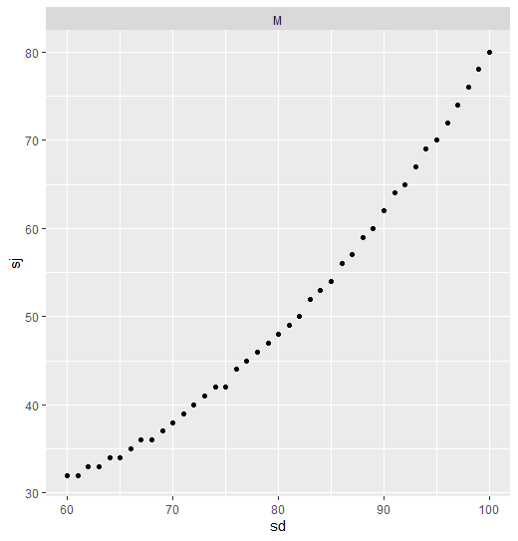
Figure 5. New plot without jitter
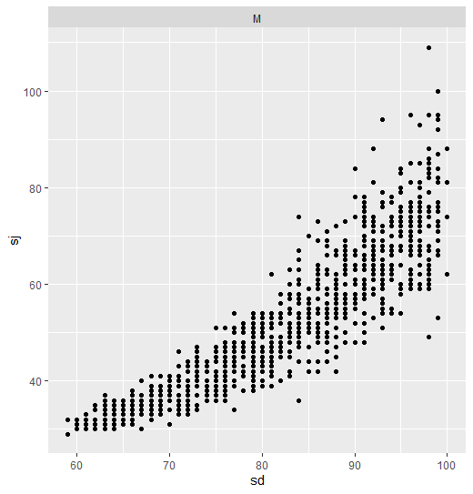
Figure 6. New plot with jitter

Fourth relationship
In the fourth relationship we have a pair of variables correlating with each other – namely jumping score (sj) and sprinting score(ss). This is done for a set of individuals that fall into three categories, the values for which can be specified as part of the parameters. For example, in this instance, like the original, the relationship is between jumping score and sprinting score for teenage females in location E. In the original dataset creator, this stood out as an especially unnatural relationship, with the two having a direct, one to one relationship which appears as a straight diagonal line on a scatter plot. The new version smooths this out, while still providing a distinct correlation between the two sets of values. It was implemented by using the standard R jitter function (with a value of 100) on the base values. Other than this, the calculation for those base values was the same as the original - the jump score is made equal to two times the sprinting score. The visual effect from this was significant despite the fairly simple modifications. There is clearly much more volume to the data which makes it appear more realistic without losing too much of the clarity in the relationship. This may be slightly more difficult to find than the original when manually searching through the data, but it should still be realistic for students in their third year of an undergraduate computing degree to find without too many issues.
The visualisations shown in Figure 7. And Figure 8. illustrate this well. In the original, you can see only a small number of dots on the plot. This is because there is a lot of overlap in the uniform line. The updated version is clearly much more varied due to the added jitter.

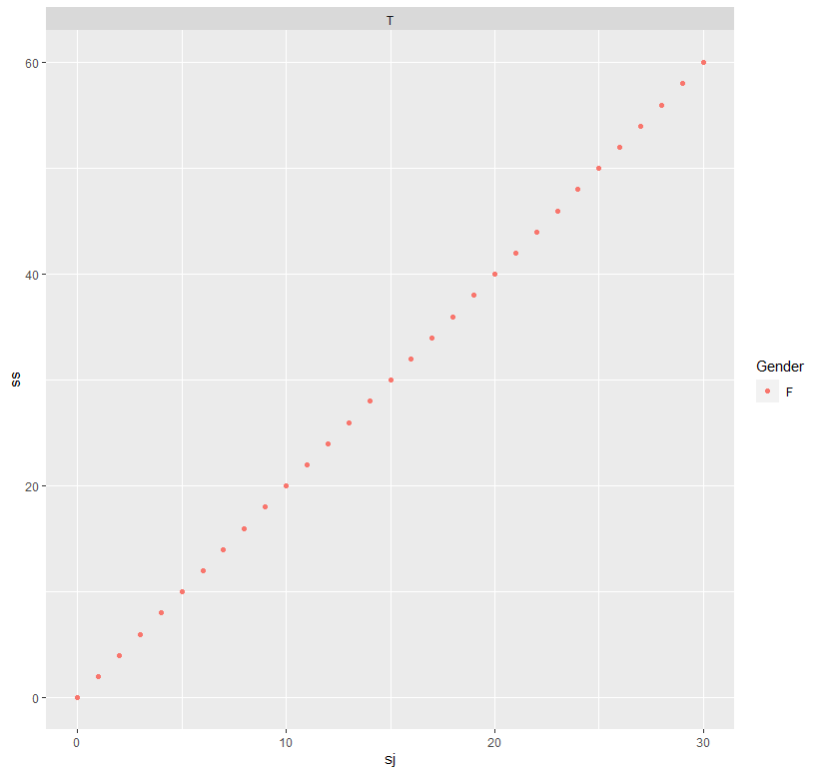
Figure 7. Original plot

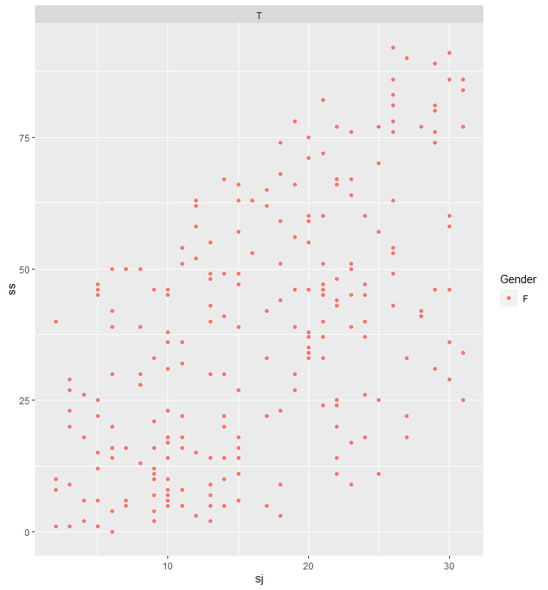
Figure 8. New plot

Fifth relationship
For the fifth relationship, there is a relationship between two numerical variables, sprinting and throwing, with a correlation between the two whereby when throwing scores improve, sprinting scores generally deteriorate. The optimisations for this relationship were also successful, visually at least, but use a different method of getting the desired results. Here we have the results from the base data being multiplied by a normal distribution, similar to the third relationship, but here it was more successful and can be modified to a greater degree without losing the relationships clarity. This meant that a standard deviation variable could be added to the parameters file to allow the user to specify how fuzzy they want the relationship to be. This will be explained in greater detail in the parameter file explanation in Section 4.3. Figure 9. and Figure 10. show the relationship generated by the original R script, and the improved version respectively. They are clearly significantly different in appearance, though they do show a similar correlation between the two numeric variables. In the original the two graphs appear identical, whereas in the new version they are slightly different. The variance is a reasonable indicator of how the tool is capable of producing subtle variations in the resulting datasets, even with the exact same parameters being applied to both locations. When comparing this and relationship three to relationship four, we can see the differences between using the standard R jitter function and the custom built solution which uses a normal distribution with specified parameters. The main difference is that the latter appears more sporadic instead of the more uniform nature of R’s jitter. The jitter function is, as mentioned on R’s documentation designed for adding some noise to a numeric vector (R Documentation, 2020). Thus, it is more suitable for increasing the visibility of data on plots when data analysis is being carried out. In contrast, the performance of the custom jitter indicates that it would be worthwhile experimenting with similar methods for more of the data creation process.
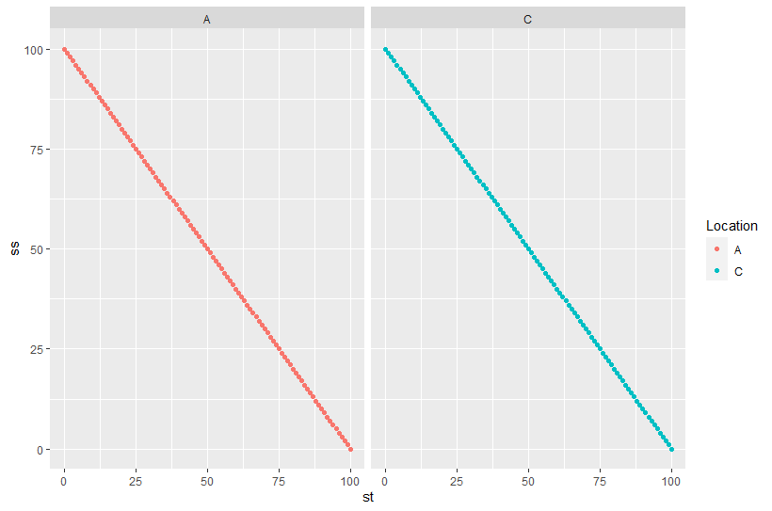
Figure 9. Original plots

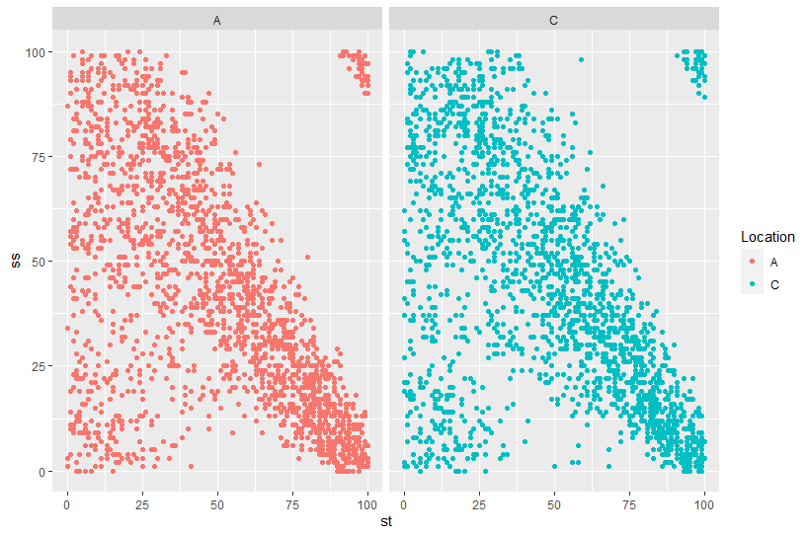
Figure 10. New plots

Sixth relationship
The sixth relationship relates to the aggregate score which combines the other numeric scores. The relationship regards the weighting of all the scores on the overall score. These weights can be set for one specified value for cat1 (gender), though when distributing it would be simple to allow this for both. This relationship involved fairly minimal alterations because there was no need to improve the way the score was calculated. The only change here was allowing the user to specify the category value and weights. This means that there is nothing particularly interesting in the visualisation of this one. Again, the ability to change values helps to create unique datasets for each new assessment or assignment, which helps to prevent students gaining an advantage by searching up previous work on the same data.

Seventh relationship
The seventh relationship is where overall scores for one location are boosted by a specified amount. Again, this is a very simple relationship which did not need much in the way of alterations to get the desired effect. The main thing that this would benefit from is a tuning of the parameters, and perhaps some more variation in the other locations to make the relationship less jarring. On the other hand, a balance needs to be struck between the data’s apparent realism and the ease with which relationships can be found. Figure 11. shows the original relationship when generated with the R script written by Peter Chapman. This is reasonable, but arguably boosts location D’s score by an excessive amount. The graph generated by the new version Figure 12. boosts it by 7% instead of the 15% of the original. This gives a less jarring appearance when visualised in a box plot, but still shows location D as being significantly separated from the others.
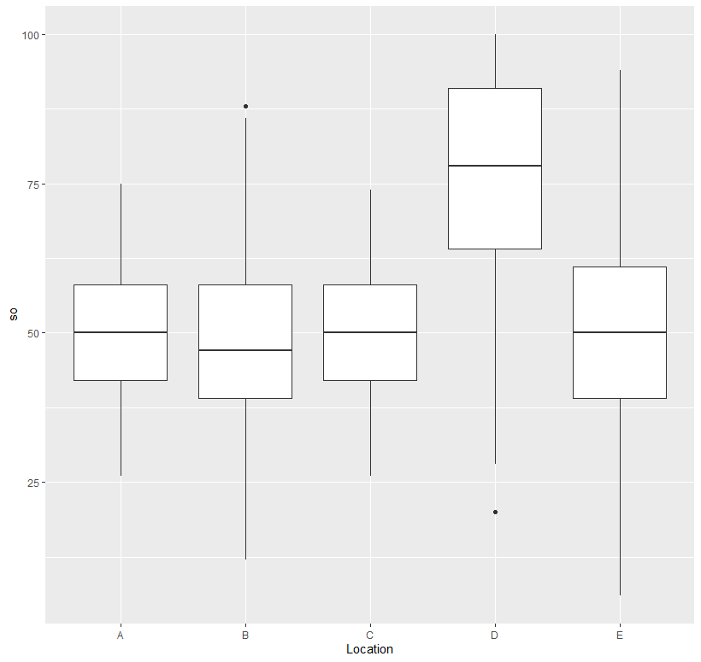
Figure 11. New plot with original values
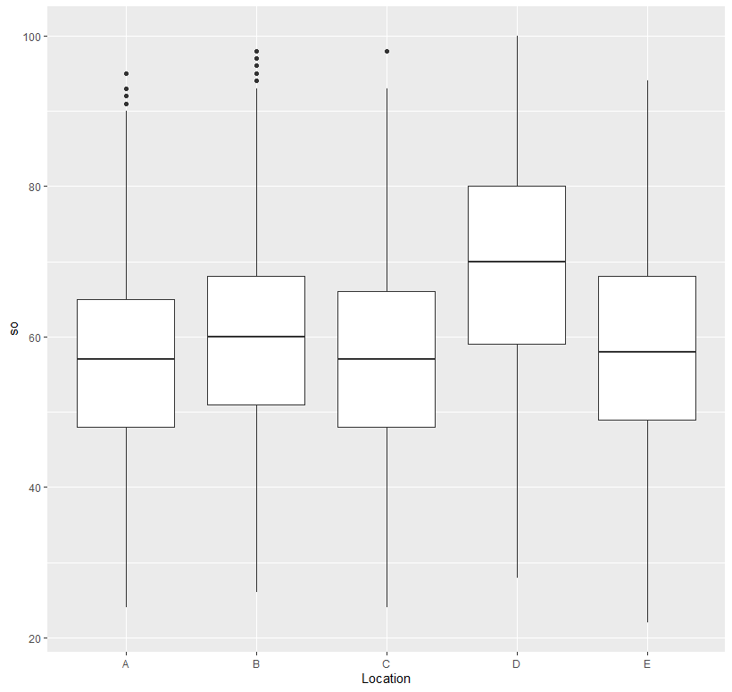
Figure 12. New plot with optimised values

The Parameter file
This will document the .csv file that was created to allow the end user to interact with the dataset creation process by specifying certain values to create unique and personalised data. The amount of things that can be specified is limited and could certainly be expanded upon in the future if desired. This may not be wanted as there are upsides and downsides to having more customisation options. One advantage of not allowing the user to specify which categorical or numeric variables are used in relationships helps to alleviate the issue of conflicts within the data as it is quite difficult to visualise this is a proven combination. The key disadvantage is of course that there are fewer options and therefore fewer possibilities for the specification of the dataset.
The parameters file has been kept as simple as possible, with descriptions for variables included where they are necessary. It begins with some general settings which apply to the whole dataset. There are three of these: value offset (the amount of jitter to be applied to relationships), MaxNum (the maximum value for numerical data, allowing users to decide whether they want to allow outliers), and Shuffle rows (gives the user the option to shuffle all rows in the dataset to make it look messier).
It then moves on to the categorical variables. This allows the user to specify what they want the names of the categorical variable columns to be, as well as the permissible values for each. This was kept the same as the original for simplicity’s sake – one categorical variable (Cat1) has two values, Cat2 has five, and Cat3 has four. The numerical columns (labelled and referred to as Num1, Num2, Num3, Num4, and Num5) at this point just have the name as a specifiable value. In the future it would not be too challenging to allow different maximum values for each of these, though it would require some changes to be made to the R script to enable these to work. There is a blank space after these so that more global parameters can be added.
Now that these initial steps are completed, the relationships can be specified.

Relationship one
This has functionality to change the minimum and maximum values for Num4 for each of the categories in Cat3.

Relationship two
This again allows the minimum and maximum values to be set for each category in Cat3, this time for the Num2 variable. It also adds a parameter for Cat1, allowing the user to specify which of the two values they want to apply this relationship to.

Relationship three
The third one changes things up, allowing the user to input desired values for Cat1 and Cat2 for a relationship between two pre-set numerical variables.

Relationship four
For this one, the user can specify values for all three categorical variables, again for a relationship between two pre-set numerical variables. These were set as it helps to reduce the knowledge and care needed to create these datasets by reducing the chance of conflicts.

Relationship five
This one allows two values from Cat2 to be specified for a relationship between two numerical variables. It also adds a standard deviation parameter which controls how fuzzy the relationship is.

Relationship six
Relationship six has parameters for controlling the weighting when calculating the aggregate score for Num5. It also allows the user to specify which value for Cat1 they want this to apply to.

Relationship seven
This one enables specification of one value from Cat2 and the amount as a percentage that the overall (aggregate) score is boosted for that collection of values.

The testing version of the tool
For analysis of the created datasets, it was necessary to make some changes to the dataset generator which would not need to be included as part of the distributable version.
This begins with looping through the whole data creation process to create multiple datasets. This allows the user to specify how many times this loop is to run and therefore, how many datasets will be created. At the end of this, but still in the loop, it will create one regular version of the dataset with a name according to the iteration that it is on.
After this, a numerical version of the dataset is created. This is more suitable for some algorithms which may be used in the evaluation process. It involves converting the variables that are suitable for conversion into numeric, and making the others null. As this was just being used for testing and comparison to the original, it was acceptable to specify exactly which were suitable according to their names in the original dataset. For example, Age is suitable for conversion to an ordered numerical variable whereas gender, unless one is of a particular, morally questionable, predisposition, is not. The dataset is then saved, again using the number of the current iteration, but this time with “Numeric” as a suffix.
Next, a nominal version of the dataset is created. This allows all variables to be converted. In this instance, the numerical variables were grouped into five sets – 0 to 20, 20 to 40, 40 to 60, 60 to 80, and 80 to 100. This means that the whole dataset can be used in algorithms, of which there are evidently many, which only accept nominal data. Again, the files are saved as the iteration number followed by a suffix, this time imaginatively named “Nominal”.

Issues encountered
During the implementation of this program, alongside the rest of the project there were a reasonable number of setbacks and problems. One key one is that the results in this very section were restricted somewhat: the records of this part of the project were not well maintained or organised. This will be discussed in the following section, Project Management, and what was written down or recalled shall be detailed here.
- It was realised that using computers to evaluate what looks “believable” and “natural” was not wise. An attempt at using Weka to analyse the data has been included, but an -objective-as-far-as-possible human analysis was also carried out.
- Getting C# to write the R code (as was the original plan) turned out to be more challenging and time consuming, due to certain parts of the R code activating things in C#. For example, the quotation marks would end the string, along with various combinations of slash and another character. This was solved by instead programming the R script to accept parameters, then compiling a .csv file for the user to input these values.
- For the relationships, certain things were not able to be converted into parameters. For example, relationships had to be between specific variables. For example, the user cannot specify whether a relationship is between Cat1 and Num4, or Cat2 and Num4. This restricts the amount that can be done in terms of specification by the user. No way around this was found, the problem being that R does not allow variables to be… variables i.e. it is not possible to change the variable name dynamically. This problem would require some significant workaround but this would be worthwhile to look into if the tool is to be worked on further.
- Values were going outside the range set due to the increased randomness and jitter functions being used. This was solved by using the mod function in R (%%Max). This takes values that are greater than the specified maximum value and places them in at the other end of the dataset. The default minimum is 0, so it was not necessary to change this.
- When trying to use Weka for evaluation, algorithms generally didn’t work with the mixture of numerical and nominal data that the created datasets consist of. This was overcome by creating a new version of the dataset creation tool which would generate a set number of datasets and convert them to both nominal and numeric versions to save alongside the originals.

Project management
The management for this project was a mixed bag. On one hand all meetings were attended and went well overall, with a fairly regular schedule of one meeting per week where this was possible. The discussions in these meetings were constructive and created better clarity over the direction to take over the next week(s). Diaries were kept from midway through the first batch of meetings (September – December), and the whole way through the meetings during the second trimester (January – May, with extension till August). Due to recent global happenings, there was a blanket deferral system in place which meant that the project was continued beyond the original April deadline. Meetings continued on a regular basis until mid-April, with a switch to online in mid-March. From this point onwards, meetings were had when they were needed, on a more irregular basis.
On the other hand, the diaries that were kept were not professional in presentation. The provided template was used, but the notes generally did not follow the structure of this. The way they were written meant that while they were useful at the time as a reminder of the work to be done, they are difficult to translate into the progress that was made during a particular timeframe. This has made looking back on them unhelpful for the write up of this report.
In addition to this, time management for the project has been sub-par. Parts of the project have overlapped each other where they were not supposed to. For instance, the Literature review was originally planned to be over with within the first month of the project but was still being worked on through the third month. The writing of this report (aside from the aforementioned literature review) didn’t properly start until April, with the bulk of it being completed in July and August. The coding part started back at the beginning in September but consisted mostly of rough experiments which were not well documented. This was mostly completed in February and March, but small tweaks were made up until August.
Overall, the management of this project was underwhelming, and should have focussed more on setting deadlines for components to be completed by. While the meetings were well managed and constructive, many other parts were lacking. As Parkinson’s law (Parkinson, 1955) dictates, "work expands so as to fill the time available for its completion", and this has been very clear during this project. The diary sheets should also have taken more information about the stage of the project at the time they were taken. This would have aided the writing of the report as the timeline of the project would be far clearer.

Evaluation
The evaluation for this project consists of two main parts. There is some objective visual evaluation in the previous section which suggests how well the dataset and the plots produced from it look in terms of believability and apparent realism. The other part is an objective look at how well the data performs when analysed with data mining software. In this case, Weka shall be used for these experiments. Weka provides algorithms for classification and regression problems, both of which have been considered here. Classification produces labels for its problem, putting data into groups with similar properties, whereas regression provides a more specific description of a problem (Strobl et. al, 2009). As the experimenter provides less specific information about these problems in both categories, the main evaluation has been done using the Weka Explorer mode instead. The disadvantage to this is that there is much more human input time required to set this up, as each dataset has to be put forward as an individual, manually. This contrasts with Weka Experimenter’s ability to run for multiple datasets concurrently, meaning it can be left to compute for however much time is necessary to complete the job. These results are then added to a file with the findings. For Weka explorer, the results have to be analysed individually for each dataset after running each algorithm on them. This limits the number of datasets that can be used in comparisons due to the increased time taken to work with them.

Visual and objective analysis
From a visual standpoint, as seen in the previous chapter when discussing the plots generated by the tool, the updates to the R script have made a sizeable difference to the data that is generated. Visualisations generated for specific parts of the data have much more noise than before, while still showing clear correlations and patterns which are easily recognised.

Comparison with IPO
With regards to the Initial Project Overview, which was created upon this project’s inception, we can compare how the tool stacks up against the desired functionality. The original document says that this project should be able to “produce a reliable, useful tool to create randomly generated but believable datasets”. When considering this it is clear that the tool that has been developed does indeed meet these briefs to a satisfactory degree.
It is reliable: upon each run it produces a dataset with the desired relationships as specified in the parameters file, as is evidenced by the testing version of the tool, which produces a specified number of unique datasets. A sample set of 90 datasets (30 originals each with a nominal and numerical version) has been included in the .zip file. The aspect of it that is not as reliable as it could be is the lack of prevention methods to stop the user from inputting values in the parameters that result in poor data which is either too fuzzy for students at this level to analyse, or is too unnatural. Thus, the user is required to have a reasonable knowledge of what they are doing. There are functions to prevent values from going outside the specified range, but more controls would be a worthwhile improvement if the time and resources available allow.
It is useful: the datasets generated are of similar specification to the dataset originally distributed to students of the Data Analytics’ module for analysis as their first coursework. This means that this tool could be used by the module leader to create new datasets for subsequent years. The tool’s ability to rapidly generate unique datasets significantly reduces the amount of work that said module leader has to put in to create a new coursework dataset compared to doing the whole thing manually by creating or editing a messy R script.
It is capable of creating randomly generated and believable datasets: for this one it is slightly harder to judge because the believable part is largely a subjective matter. However, the increased noise in relationships does undeniably make them less jarring and obvious than they were previously, as can be seen and judged by the reader from the plots in section 4.2. The “randomly generated part” is more objectively quantifiable, and indeed there is significant usage of pseudorandom number generators through uniform and normal distributions. With the benefit of hindsight, it was not a particularly good objective, as it is not actually achievable because true randomness cannot be generated by computers at the moment.
One key omission from the original IPO deliverables is “A report on how optimal values were picked”. This was omitted as it was not really quantifiable. For this tool, the truth is that there are no ‘optimal values’, merely values which fit their intended purpose well. A few records on this topic are mentioned in the parameters file, though these are more just rough guidelines to prevent the user from specifying values which would create broken or unclear data that would be difficult to analyse.

Comparison with Aims and objectives
Now to compare this with the original aims set out at the beginning of this report. To recap, these were as follows:
- gaining an understanding of data and randomness
- Being able to create synthetic data that is close in appearance to real data.
- Making a synthetic dataset generator tool that gives sufficient control to the creator of the dataset
- Minimising the amount of time required to create the data
- Providing options for specifying relationships within the data, naming categories, and the amount that the data is fuzzified – i.e. how much random jitter is applied to the values to imitate real data.
Again, the project has achieved these key aims to an acceptable degree.
The literature review vastly increased understanding of data and randomness, adding a great depth of knowledge which could be applied to the implementation and evaluation of this project. It also helped by giving a better perspective of the ideas set out in the IPO, and influenced some changes to the objectives that were completed.
Again, the tool is capable of creating synthetic data that is close in appearance to real data, though a ideal evaluation of this would require a significant amount of extra work which will be discussed in the future work section. It does provide a large amount of customisation options for the user to specify the dataset to their own needs, so it has achieved that goal.
The amount of time and effort required to create a dataset is also minimal. This could potentially be improved by the introduction of a graphical user interface (GUI) to input the parameters. As a result, this aim was completed to an extent, but would benefit from some additional work.
For the customisability of the dataset, again it arguably did achieve the goal that was set out from the start as the parameters file provides countless options for changing the relationships and specifying them to be as desired, but there are some aspects, such as the number of relationships that are included. This is not too much of an issue for the original purpose as part of an undergraduate computing module because the difficulty of the coursework would ideally be very close each year, but it would be a useful addition to the functionality to enable a greater breadth of potential use-cases for the tool.

Weka Explorer Analysis
These experiments were run using Weka’s Explorer feature. The specified relationships were taken into account, then the datasets were run through Weka using the J48 algorithm and the relationships were manually searched for in the tree produced by said algorithm. This part of the evaluation is mostly useful for determining whether relationships can be found in the data, not so much for whether they look realistic.
The relationships investigated here are Relationship 1 (where one age category performs better in distance), Relationship 3 (Correlation between jumps and distance scores in males in location B), and Relationship 7 (Location D has higher overall scores than other locations). The data shall be gathered and presented in Table 1., then analysed. The raw data from these experiments is included in the .zip file due to the large quantity of text that the J48 tree produces. As the testing procedure was refined throughout the course of running these experiments (by selecting only certain categories), the data presentation varies a little, but they all contain equivalent data. the first value for the fractions is the amount of entries in this category, the second is the number of cases that break the rule.
Dataset | REL 1 | REL 3 | REL 7
1 | Age = O: 80-100 (2500.0/422.0) | sj = 60-80, sd = 80-100: M (405.21/153.0)  sj 20-40, sd = 60-80 Location = B: M (382.0/143.0) | Location = A: 40-60 (2000.0/946.0)  Location = B: 40-60 (2000.0/1049.0)  Location = C: 40-60 (2000.0/931.0)  Location = D: 60-80 (2000.0/1082.0)  Location = E: 40-60 (2000.0/1090.0)
2 | Age = O: 80-100 (2500.0/377.0) | sj = 40-60, Gender = M: B (1230.21/795.0)  sd = 60-80  | | Gender = M: B (571.0/348.0) | Location = A: 40-60 (2000.0/913.0)  Location = B: 40-60 (2000.0/1088.0)  Location = C: 40-60 (2000.0/951.0)  Location = D: 60-80 (2000.0/1032.0)  Location = E: 40-60 (2000.0/1089.0)
3 | Age = T: 60-80 (2500.0/1249.0)  Age = U: 60-80 (2500.0/1236.0)  Age = L: 60-80 (2500.0/1213.0)  Age = O: 80-100 (2500.0/640.0) | sj = 40-60 sd = 80-100: M (186.0/83.0)  sj = 60-80 sd = 80-100 Location = B: M (396.23/145.0) | Location = A: 40-60 (2000.0/992.0)  Location = B: 40-60 (2000.0/1065.0)  Location = C: 40-60 (2000.0/927.0)  Location = D: 60-80 (2000.0/1081.0)  Location = E: 40-60 (2000.0/1050.0)
4 | Age = T: 60-80 (2500.0/1201.0)  Age = U: 60-80 (2500.0/1223.0)  Age = L: 60-80 (2500.0/1255.0)  Age = O: 80-100 (2500.0/666.0) | sj = 40-60  | Gender = M: 80-100 (1260.21/567.0)  sj = 60-80, | Location = B, | | sd = 80-100: M (397.22/140.0) | Location = A: 40-60 (2000.0/945.0)  Location = B: 40-60 (2000.0/1060.0)  Location = C: 40-60 (2000.0/935.0)  Location = D: 60-80 (2000.0/1075.0)  Location = E: 40-60 (2000.0/1111.0)
5 | Age = T: 60-80 (2500.0/1257.0)  Age = U: 60-80 (2500.0/1243.0)  Age = L: 80-100 (2500.0/1247.0)  Age = O: 80-100 (2500.0/622.0) | sj = 40-60: M (2056.0/845.0)  sj = 60-80  | sd = 80-100  , | | Location = B: M (431.0/161.0) | Location = A: 40-60 (2000.0/967.0)  Location = B: 40-60 (2000.0/1073.0)  Location = C: 40-60 (2000.0/942.0)  Location = D: 60-80 (2000.0/1093.0)  Location = E: 40-60 (2000.0/1085.0)
6 | Age = T: 80-100 (2500.0/1250.0)  Age = U: 60-80 (2500.0/1254.0)  Age = L: 60-80 (2500.0/1255.0)  Age = O: 80-100 (2500.0/647.0) | N/A | Location = A: 40-60 (2000.0/899.0)  Location = B: 40-60 (2000.0/1074.0)  Location = C: 40-60 (2000.0/909.0)  Location = D: 60-80 (2000.0/1100.0)  Location = E: 40-60 (2000.0/1093.0)
7 | Age = T: 80-100 (2500.0/1200.0)  Age = U: 60-80 (2500.0/1235.0)  Age = L: 60-80 (2500.0/1282.0)  Age = O: 80-100 (2500.0/363.0) | N/A | Location = A: 40-60 (2000.0/920.0)  Location = B: 40-60 (2000.0/1100.0)  Location = C: 40-60 (2000.0/962.0)  Location = D: 60-80 (2000.0/1100.0)  Location = E: 40-60 (2000.0/1047.0)
8 | Age = T: 60-80 (2500.0/1220.0)  Age = U: 60-80 (2500.0/1254.0)  Age = L: 80-100 (2500.0/1194.0)  Age = O: 80-100 (2500.0/468.0) | N/A | Location = A: 40-60 (2000.0/952.0)  Location = B: 40-60 (2000.0/1072.0)  Location = C: 40-60 (2000.0/914.0)  Location = D: 60-80 (2000.0/1099.0)  Location = E: 40-60 (2000.0/1098.0)
9 | Age = T: 80-100 (2500.0/1269.0)  Age = U: 60-80 (2500.0/1246.0)  Age = L: 80-100 (2500.0/1212.0)  Age = O: 80-100 (2500.0/391.0) | N/A | Location = A: 40-60 (2000.0/964.0)  Location = B: 40-60 (2000.0/1078.0)  Location = C: 40-60 (2000.0/968.0)  Location = D: 60-80 (2000.0/1081.0)  Location = E: 40-60 (2000.0/1126.0)
10 | Age = T: 60-80 (2500.0/1187.0)  Age = U: 60-80 (2500.0/1293.0)  Age = L: 80-100 (2500.0/1246.0)  Age = O: 80-100 (2500.0/553.0) | N/A | Location = A: 40-60 (2000.0/931.0)  Location = B: 40-60 (2000.0/1042.0)  Location = C: 40-60 (2000.0/934.0)  Location = D: 60-80 (2000.0/1065.0)  Location = E: 40-60 (2000.0/1108.0)
11 | Age = T: 60-80 (2500.0/1227.0)  Age = U: 60-80 (2500.0/1300.0)  Age = L: 60-80 (2500.0/1183.0)  Age = O: 80-100 (2500.0/414.0) | N/A | Location = A: 40-60 (2000.0/947.0)  Location = B: 40-60 (2000.0/1089.0)  Location = C: 40-60 (2000.0/945.0)  Location = D: 60-80 (2000.0/1078.0)  Location = E: 40-60 (2000.0/1140.0)
12 | 80-100 (10000.0/4324.0) | N/A | Location = A: 40-60 (2000.0/954.0)  Location = B: 40-60 (2000.0/1086.0)  Location = C: 40-60 (2000.0/954.0)  Location = D: 80-100 (2000.0/1109.0)  Location = E: 40-60 (2000.0/1103.0)
13 | Age = T: 60-80 (2500.0/1250.0)  Age = U: 60-80 (2500.0/1177.0)  Age = L: 60-80 (2500.0/1225.0)  Age = O: 80-100 (2500.0/632.0) | N/A | Location = A: 40-60 (2000.0/930.0)  Location = B: 40-60 (2000.0/1052.0)  Location = C: 40-60 (2000.0/936.0)  Location = D: 60-80 (2000.0/1094.0)  Location = E: 40-60 (2000.0/1080.0)
14 | Age = T: 60-80 (2500.0/1304.0)  Age = U: 60-80 (2500.0/1275.0)  Age = L: 80-100 (2500.0/1229.0)  Age = O: 80-100 (2500.0/458.0) | N/A | Location = A: 40-60 (2000.0/916.0)  Location = B: 40-60 (2000.0/1057.0)  Location = C: 40-60 (2000.0/941.0)  Location = D: 60-80 (2000.0/1128.0)  Location = E: 40-60 (2000.0/1076.0)
15 | Age = T: 60-80 (2500.0/1256.0)  Age = U: 60-80 (2500.0/1182.0)  Age = L: 60-80 (2500.0/1223.0)  Age = O: 80-100 (2500.0/587.0) | N/A | Location = A: 40-60 (2000.0/945.0)  Location = B: 40-60 (2000.0/1092.0)  Location = C: 40-60 (2000.0/925.0)  Location = D: 60-80 (2000.0/1043.0)  Location = E: 40-60 (2000.0/1087.0)
16 | Age = T: 80-100 (2500.0/1216.0)  Age = U: 60-80 (2500.0/1240.0)  Age = L: 60-80 (2500.0/1298.0)  Age = O: 80-100 (2500.0/570.0) | N/A | Location = A: 40-60 (2000.0/919.0)  Location = B: 40-60 (2000.0/1070.0)  Location = C: 40-60 (2000.0/894.0)  Location = D: 60-80 (2000.0/1050.0)  Location = E: 40-60 (2000.0/1040.0)
17 | Age = T: 60-80 (2500.0/1212.0)  Age = U: 60-80 (2500.0/1215.0)  Age = L: 60-80 (2500.0/1231.0)  Age = O: 80-100 (2500.0/477.0) | N/A | Location = A: 40-60 (2000.0/934.0)  Location = B: 40-60 (2000.0/1082.0)  Location = C: 40-60 (2000.0/963.0)  Location = D: 60-80 (2000.0/1089.0)  Location = E: 40-60 (2000.0/1114.0)
18 | Age = T: 60-80 (2500.0/1205.0)  Age = U: 60-80 (2500.0/1275.0)  Age = L: 80-100 (2500.0/1215.0)  Age = O: 80-100 (2500.0/501.0) | N/A | Location = A: 40-60 (2000.0/867.0)  Location = B: 40-60 (2000.0/1036.0)  Location = C: 40-60 (2000.0/945.0)  Location = D: 60-80 (2000.0/1073.0)  Location = E: 40-60 (2000.0/1044.0)
19 | Age = T: 60-80 (2500.0/1266.0)  Age = U: 80-100 (2500.0/1216.0)  Age = L: 80-100 (2500.0/1244.0)  Age = O: 80-100 (2500.0/719.0) | N/A | Location = A: 40-60 (2000.0/935.0)  Location = B: 40-60 (2000.0/1107.0)  Location = C: 40-60 (2000.0/969.0)  Location = D: 60-80 (2000.0/1101.0)  Location = E: 40-60 (2000.0/1158.0)
20 | Age = T: 80-100 (2500.0/1176.0)  Age = U: 60-80 (2500.0/1242.0)  Age = L: 60-80 (2500.0/1192.0)  Age = O: 80-100 (2500.0/451.0) | N/A | Location = A: 40-60 (2000.0/941.0)  Location = B: 40-60 (2000.0/1051.0)  Location = C: 40-60 (2000.0/932.0)  Location = D: 60-80 (2000.0/1068.0)  Location = E: 40-60 (2000.0/1126.0)
Table 1.
The findings from this reveal that while relationships one and seven were clear enough, relationship three with its greater combination of variables was much more difficult to analyse. This is due to the large increase in data presented by Weka upon running the algorithm. Due to the complexity and time required to get data from relationship 3, it was abandoned after the first five runs. From what was gathered, we can see that there was some evidence of relationships, but often the algorithm put results into larger groups, concealing this information. As a result, it is not fair to say that the tool succeeded in this regard, as it is not reasonable to say that: it didn’t give me the results I wanted, therefore it’s wrong. However, given that there was no evidence provided to say that the relationships were not there, it is also not fair to say that the tool failed here either. In truth, getting optimal results from more complex relationships such as this one takes a greater knowledge of Weka and a vast amount of time.
For relationship one, the results were far more promising. The first two examples were taken from running the tree on the entire dataset, with the testing method being refined to just include the variables that are included in the relationship specified thereafter. These initial results were kept, though, as they told an interesting story. When searching through the dataset, these were picked out as all-encompassing “rules”, whereas the other age groups were split into many different branches for all the different variables. This is a clear indication that the relationship is strong enough to be found by students analysing these datasets. From here on, the results were reasonably consistent: the particular age category stood out in all but the twelfth category, which grouped all age groups into one class with a relatively low accuracy. Although this only happened in one out of the twenty sets tested, it does suggest that this relationship could be made clearer still to ensure it is consistently picked up. It does not give any indication that the relationship was not present in this instance, however, and most likely was caused by the broad categories used in this nominal version of the dataset – each one covers 20 numbers, so accuracy is lost. A more common variation was for other age groups to also belong to the 80-100 category, but the accuracy for these was far lower, so the desired ‘O’ group was still distinct from the others.
For the seventh relationship, things were more consistent, with the groups found being the same in all but one instance. This was where location D was in the 80-100 category, instead of the 60-80 category it was placed in for the other nineteen datasets. In all cases, the other four locations were in the 40-60 category, with fairly small variations in the confidence. This all shows that this relationship is clearly and consistently picked out by Weka, and thus would be fairly easy for a student to discover.
For this evaluation, we have learned that the tool does produce datasets with relationships that can be picked up through Weka. While not perfect, Weka has proven a useful tool to determine which relationships can be picked up and which it struggles with. To expand on this work, it would be useful to gain some human data, as it is difficult to translate Weka’s automated searching for rules and groups in the data into people manually searching through the same data using R as the students in the Data Analytics module currently do.

Conclusions and future work

Objective summary of the project
As a whole, this project was successful. In spite of some setbacks; most notably the underwhelming project management, as well as a reduction to the scope, the project was able to reach the goals set at the beginning for the most part.
The literature review section significantly broadened the knowledge of various terms and tools, helping us to understand randomness, pseudorandomness, and the differences and similarities between the two.

Potential future extensions
From the project there are a number of additional things that would be beneficial to investigate and work on. Some ideas are described below.
- Enabling the category names to be changed in relationships – as mentioned previously, the program currently only allows the user to input values for a pre-set category when regarding relationships.
- For evaluation purposes, it would be worthwhile to conduct a survey. This would involve asking people (ideally including some Data Analysts) their thoughts on the data and how natural it looks. This would be useful as making the data look realistic and natural was a key part of the project, but this is impossible to quantify using just computers which limited the effectiveness of the evaluation segment of this report.
- As a further survey, students could be asked to analyse some of the data to determine how easily they can detect the relationships in datasets that have been generated by the tool.
- Developing the tool further to turn it into a commercially viable piece of software: as this project is part of a Computing Science degree, rather than a Software Engineering one, the development stage focussed more on experimentation to see what different techniques and values produced in terms of results. Despite this, the tool shows potential to be genuinely useful, but it would certainly benefit from some further testing and protection against errors for greater stability. In addition to these…
- … A GUI would be another worthwhile development. This would make the experience of creating a dataset more refined and user-friendly, in the process making it more professional in its presentation. This GUI was originally planned as part of the project and would consist of a C# Windows platform app that had a simple form with clear labelling and constraints to prevent the user from entering values that would not work. This could also be done in a different language, and may benefit from doing so as the aforementioned concept would only work natively on Microsoft Windows, whereas the R script could also run on Linux or MacOS/MacOSX/OSX/Whatever it is called this week.

Lessons learned
From this project, significant amount of knowledge was gained through the research and experiences that this project consisted of.
- The understanding of randomness and pseudorandomness was much improved as part of the research conducted as part of this project.
- A greater knowledge of R was gained, with many useful functions being learned about which may prove useful in future projects.
- The importance of putting effort into the planning of the project from the start was emphasised. In particular, it is important to think about exactly how the project can be evaluated, as the method chosen at the beginning was not perfectly suited to the task.

References
Bradley, M. T., & Brand, A. (2016). Accuracy when inferential statistics are used as measurement tools. BMC Research Notes, 9(1). https://doi.org/10.1186/s13104-016-2045-z
Chiang, F., & Gairola, D. (2018). InfoClean: Protecting sensitive information in data cleaning. Journal of Data and Information Quality, 9(4). https://doi.org/10.1145/3190577
Costa, C., Freitas, Â., Stefanik, I., Krafft, T., Pilot, E., Morrison, J., & Santana, P. (2019). Evaluation of data availability on population health indicators at the regional level across the European Union. Population Health Metrics, 17(1). https://doi.org/10.1186/s12963-019-0188-6
Dalalyan, A. S. (2017). Theoretical guarantees for approximate sampling from smooth and log-concave densities. In Journal of the Royal Statistical Society. Series B: Statistical Methodology (Vol. 79). https://doi.org/10.1111/rssb.12183
Frank, E., Hall, M., Trigg, L., Holmes, G., & Witten, I. H. (2004). Data mining in bioinformatics using Weka. Bioinformatics, 20(15), 2479–2481. https://doi.org/10.1093/bioinformatics/bth261
Heinrich, B., Klier, M., Schiller, A., & Wagner, G. (2018). Assessing data quality – A probability-based metric for semantic consistency. Decision Support Systems, 110, 95–106. https://doi.org/10.1016/j.dss.2018.03.011
Homework. (2012). Introduction to Python Programming Language. Retrieved 28 July 2020, from EEDP , A-course website: https://dl.acm.org/doi/book/10.5555/2789339
jitter function | R Documentation. (n.d.). Retrieved 2 August 2020, from https://www.rdocumentation.org/packages/base/versions/3.6.2/topics/jitter
Ladouceur, R., Ferland, F., & Maude Fournier, P. (2013). Correction of erroneous perceptions among primary school students regarding the notions of chance and randomness in gambling. American Journal of Health Education, 34(5), 272–277. https://doi.org/10.1080/19325037.2003.10603560
MANOJ, G., RAVI, K. B., & PRAKASH, K. R. (2018). Designing a Software Test Automation Framework for Windows Application Using Coded Ui in Visual Studio Tool and Page Object Design. In i-manager’s Journal on Software Engineering (Vol. 12). https://doi.org/10.26634/jse.12.4.14703
Meinert, M. C. (2018). These Four Letters Could Spell a Compliance Headache for Smaller Banks Breaking down the wide-reaching implications of Europe’s new data privacy regulation. In ABA Banking Journal.
Microsoft. (2017). C# Guide | Microsoft Docs. Retrieved 18 November 2019, from Microsoft Documentation website: https://docs.microsoft.com/en-us/dotnet/csharp/
Moeckel, R. (2018). Simple Integrated Land Use Orchestrator. Retrieved 9 July 2020, from https://silo.zone/index.html
Nowok, B., Raab, G. M., & Dibben, C. (2016). Synthpop: Bespoke creation of synthetic data in R. Journal of Statistical Software, 74. https://doi.org/10.18637/jss.v074.i11
Package Management Tool [R package pacman version 0.5.1]. (n.d.). Retrieved from https://cran.r-project.org/package=pacman
Random | Definition of Random by Merriam-Webster. (n.d.). Retrieved 26 November 2019, from https://www.merriam-webster.com/dictionary/random
Rapidminer. (2018). Data Preparation: Time consuming and tedious? Retrieved 23 January 2020, from Rapidminer website: https://rapidminer.com/blog/data-prep-time-consuming-tedious/
Reimers, S., Donkin, C., & Le Pelley, M. E. (2017). Original Articles Perceptions of randomness in binary sequences: Normative, heuristic, or both? https://doi.org/10.1016/j.cognition.2017.11.002
Renard, D. (2011). Roger S. Bivand, Edzer J. Pebesma, Virgilio Gomez-Rubio: Applied Spatial Data Analysis with R. Mathematical Geosciences, 43(5), 607–609. https://doi.org/10.1007/s11004-011-9340-y
Smith, D. M., Clarke, G. P., & Harland, K. (2009). Improving the synthetic data generation process in spatial microsimulation models. Environment and Planning A, 41(5), 1251–1268. https://doi.org/10.1068/a4147
Strobl, C., Malley, J., & Tutz, G. (2009). An Introduction to Recursive Partitioning: Rationale, Application, and Characteristics of Classification and Regression Trees, Bagging, and Random Forests. Psychological Methods, 14(4), 323–348. https://doi.org/10.1037/a0016973
Team, R. C. (2013). The R Project for Statistical Computing. Retrieved 12 November 2019, from Http://Www.R-Project.Org/ website: https://www.r-project.org/
TIOBE. (2020). index | TIOBE - The Software Quality Company. Retrieved 28 July 2020, from https://www.tiobe.com/tiobe-index/
Turner, B. M., Sederberg, P. B., Brown, S. D., & Steyvers, M. (2013). A Method for efficiently sampling from distributions with correlated dimensions. https://doi.org/10.1037/a0032222
University of Waikato. (2016). Weka 3 - Data Mining with Open Source Machine Learning Software in Java. Retrieved 13 July 2020, from The University of Waikato website: https://www.cs.waikato.ac.nz/ml/weka/%0Ahttp://www.cs.waikato.ac.nz/ml/weka/
V, E. I., Hidalgo, M., Mart, A., & Almanza, N. (2015). A Data Preparation Methodology in Data Mining. J Med Syst, 39, 152. https://doi.org/10.1007/s10916-015-0312-5
Vadhan, S. P. (2011). Pseudorandomness. Foundations and Trends in Theoretical Computer Science, 7(1–3), 1–336. https://doi.org/10.1561/0400000010
Velmurugan, T., & Santhanam, T. (2016). Performance Analysis Of K-Means And K- Medoids Clustering Algorithms For A Randomly Generated Data Set. In International Conference on Systemics, Cybernetics and Informatics. Retrieved from https://www.researchgate.net/publication/234136053
Vose, M. D. (1991). A linear algorithm for generating random numbers with a given distribution. In IEEE Transactions on Software Engineering (Vol. 17). https://doi.org/10.1109/32.92917
Warren, P. A., Gostoli, U., Farmer, G. D., El-Deredy, W., & Hahn, U. (2018). A re-examination of ‘Bias’ in human randomness perception. Journal of Experimental Psychology: Human Perception and Performance, 44(5), 663–680. https://doi.org/10.1037/xhp0000462
Withers, C. S., & Nadarajah, S. (2019). The distribution of the minimum of a positive sample. Statistics and Probability Letters, 151, 89–96. https://doi.org/10.1016/j.spl.2019.04.002

Appendix 1 Project Overview
Initial Project Overview
SOC10101 Honours Project (40 Credits)
Title of Project: Dataset generator for educational and training use
Overview of Project Content and Milestones
This project aims to produce a reliable, useful tool to create randomly generated but believable datasets. Initially, it is being designed for students at Edinburgh Napier University, to analyse in the Data Analytics module for their first coursework. It should provide the user with the ability to create a dataset with specified relationships that are clearly enough defined for the user to be able to find them, but also vague enough to appear realistic. It will involve investigating various random number generators and putting constraints on them to produce consistent results.
The Main Deliverable(s):
- A dataset generator
- A report on how optimal values were picked
- A literature review

The Target Audience for the Deliverable(s):
Teaching staff and students at Edinburgh Napier University and potentially other educational institutions.
The Work to be Undertaken:
- Research for literature review – find articles discussing different types of randomised distribution
- Write up of literature review
- Develop a basic program to generate the data that allows various parameters to be modified – most likely using R.
- Experiment with different values to find optimal settings to use for the specific application that it is being developed for (Data Analytics cw1)
- Write up honours dissertation

Additional Information / Knowledge Required:
- Learn more about how to program in R and potentially learn how to turn the program into a package that can easily be integrated into RStudio.
- Investigate different random number generators

Information Sources that Provide a Context for the Project:
Edinburgh Napier University: Data Analytics module
The Importance of the Project:
This project is important as it has the potential to significantly improve the learning experience of students as it aims to produce data that is closer to real data than the training datasets that were used before. This would mean students would be better prepared for work should they get a job in the data analysis field. It could also save a lot of time for the teaching staff as they would be able to generate a new dataset for each set of students at the click of a button.
The Key Challenge(s) to be Overcome:
- Finding enough relevant literature
- To find a way to build relationships in the data while minimising the amount of other unintended relationships that are created in the process.

Appendix 2 Second Formal Review Output


Appendix 3 Diary Sheets (or other project management evidence)
EDINBURGH NAPIER UNIVERSITY

SCHOOL OF COMPUTING

PROJECT DIARY

Student: Peter Henry Supervisor: Peter Chapman

Date: 23/01/20 Last diary date: 02/12/19

Objectives:
Work on code
Books can be used
Small claims can use newspapers as references

Progress:

Supervisor’s Comments:

EDINBURGH NAPIER UNIVERSITY

SCHOOL OF COMPUTING

PROJECT DIARY

Student: Peter Henry Supervisor: Peter Chapman

Date: 30/01/20 Last diary date:

Objectives:
Work with R parameters – rio
Cat comment cat line read line – assign to variable
Keep to original scope at this stage
Management less important

Progress:

Supervisor’s Comments:

EDINBURGH NAPIER UNIVERSITY

SCHOOL OF COMPUTING

PROJECT DIARY

Student: Peter Henry Supervisor: Peter Chapman

Date: 13/02/20 Last diary date:

Objectives:
Specify erroneous value frequency
Can weka compare multiple datasets simultaneously?

Progress:

Supervisor’s Comments:
Mention time management issues in dissertation

EDINBURGH NAPIER UNIVERSITY

SCHOOL OF COMPUTING

PROJECT DIARY

Student: Peter Henry Supervisor: Peter Chapman

Date: 27/02/20 Last diary date:

Objectives:
Use unif for most and another for outliers
Change sd for jitter
Jitter mean unif -5 to 5
Use custom jitter with rnorm for random value skewing – Set mean to a small random number.

Progress:

Supervisor’s Comments:

EDINBURGH NAPIER UNIVERSITY

SCHOOL OF COMPUTING

PROJECT DIARY

Student: Peter Henry Supervisor: Peter Chapman

Date: 05/03/20 Last diary date: 27/02/20

Objectives:
- Perhaps Use loop to alter mean for jitter function
- Index index+1 everytime a new one is required
- Keep sd low
- Norm can produce outliers – mention in report
- Focus on producing outliers
- Making the whole data creator parameter centric
- Talk about outliers in the report – include marginal and extreme ones in code

Progress:

Supervisor’s Comments:

EDINBURGH NAPIER UNIVERSITY

SCHOOL OF COMPUTING

PROJECT DIARY

Student: Peter Henry Supervisor: Peter Chapman

Date: 16/03/20 Last diary date: 05/03/20

Objectives:
- Try Weka with basic datasets soon to figure out how long it takes to analyse
- General writing of report
- Mostly write and look at evaluation
- Don’t worry about meeting attendance
- Backlog progress diary system for index

Progress:

Supervisor’s Comments:

EDINBURGH NAPIER UNIVERSITY

SCHOOL OF COMPUTING

PROJECT DIARY

Student: Peter Henry Supervisor: Peter Chapman

Date: 25/03/20 Last diary date: 16/03/20

Objectives:
In future work talk about turning spreadsheet into online form – to store the files
Program, analysis, and writing -try to move onto weka and writing

Progress:

Supervisor’s Comments:

EDINBURGH NAPIER UNIVERSITY

SCHOOL OF COMPUTING

PROJECT DIARY

Student: Peter Henry Supervisor: Peter Chapman

Date: 01/04/20 Last diary date: 25/03/20

Objectives:
Email Alistair about the deadline – when is the latest I can hand it in
Survey idea – ask people which data was generated vs one which is real

Progress:

Supervisor’s Comments:

EDINBURGH NAPIER UNIVERSITY

SCHOOL OF COMPUTING

PROJECT DIARY

Student: Peter Henry Supervisor:

Date: 25/10/19 Last diary date:

Objectives:
- Find articles to be used in the literature review - look at sampling from a distribution
- Start writing literature review
- Begin writing program to generate ‘R’ code

Progress:
- Started on program – issues with newlines and quotation marks.
- Found 5 articles on the subject of sampling from a distribution that can potentially be used in the literature review

Supervisor’s Comments:

EDINBURGH NAPIER UNIVERSITY

SCHOOL OF COMPUTING

PROJECT DIARY

Student: Peter Henry Supervisor:

Date: 06/11/19 Last diary date:

Objectives:
Think about evaluation of project
Lit review – write the bulk of it, with sources

Progress:

Supervisor’s Comments:

EDINBURGH NAPIER UNIVERSITY

SCHOOL OF COMPUTING

PROJECT DIARY

Student: Peter Henry Supervisor: Peter Chapman

Date: 06/11/19 Last diary date:

Objectives:
Work on citations – use cite on google scholar
Continue to write lit review
Use template from Moodle

Progress:

Supervisor’s Comments:

EDINBURGH NAPIER UNIVERSITY

SCHOOL OF COMPUTING

PROJECT DIARY

Student: Peter Henry Supervisor: Peter Chapman

Date: 18/11/19 Last diary date:

Objectives:
Construct plan of work
Interim doesn’t affect mark
Just using uniform + normal
Peter will be in on 11th

Progress:

Supervisor’s Comments:

